il whien

# Math

* **November 2** – Math Unit 2 Test
* **November 9** – Royal Agricultural Fair Trip
* **November 17** – PD Day – School Closed
* **November 21** – Picture Retake
* **November 24** – Progress Reports Go Home
* **November 30** – Parent/Teacher Interviews

Phew! We finally finished our unit 2 in math which was Whole Numbers to 10 000. What a long unit! We learned so much about rounding numbers, estimating sums and differences, adding and subtracting 3 and 4 digit numbers and even different mental math strategies. Our unit test will be on Thursday, November 2, 2016. Make sure to study!

# Important Dates

This month we wrapped up our narrative unit by learning about legends and fables, and learned about their characteristics. We read various different legends and fables and did comprehension activities for each one. Towards the end, the students created their very own legend movie poster and are in the process of writing their own fables. We can’t wait to read their stories!

For grammar, we have finished our unit on sentences and sentence structure. We are currently learning about parts of speech. We have started learned about proper and common nouns. Next up, everything pronouns!

For Art, we have done some interesting art assignments. The students have been doing amazing work with their sketchbook assignments. They have also showed their artistic sides with their negative-positive tree art. We have also created paper-weaving salah mats for our school’s Islamic Heritage gallery walk. I think we may have our next Leonardo Da Vinci on our hands!

For Health, the grade four students have been learning about the different types of threats. They also are learning about the different ways to respond to these threats.

# Friendly Reminders:

- students to are expected to be in the school building by 8:15 am and leave by 3:45 pm.

- students should bring only nut-free lunches and snacks.

- it’s getting cold! Please start wearing a

warm jacket, hats and gloves.

October-November   
newsletter

# Visual Arts/Health

### IFS Durham

October 31, 2017

Alhamdulilah we’ve had great month learning, exploring and having fun! We also received our first taste of autumn with some chilly, windy days. Brrrr!

Besides coping with the new cold weather, we’ve been busy learning about many new things and doing activities that were engaging and challenging at the same time.

# Language

# It’s been a great month!

banner with apples and crayons

Sr. Hadil’s Classroom Newsletter

And the Star Student award goes to…

Mohammad Hassanuddin

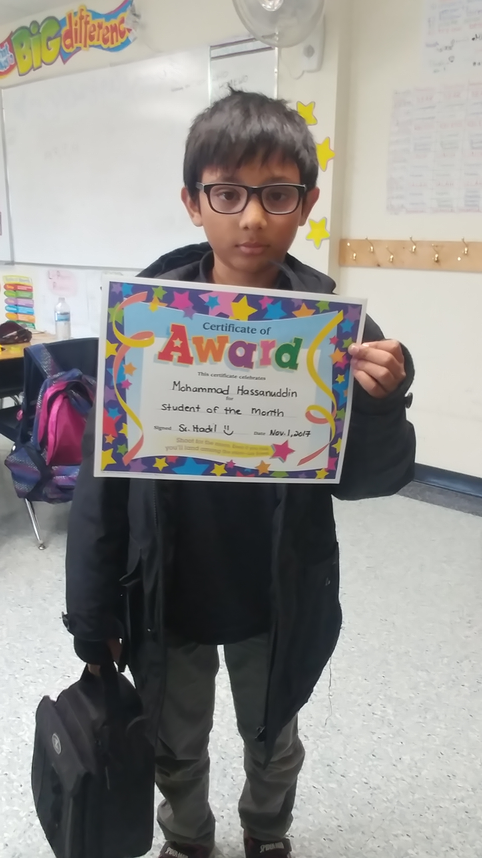

Visit our classroom website at [www.grade4ifs-durham.weebly.com](http://www.grade4ifs-durham.weebly.com)

We are currently continuing our unit on the Political and Physical Regions of Canada. We learned many interesting facts about the different provinces and territories. Did you know that Manitoba is considered a key-stone province because it is surrounded by land?

We will continue to learn about the various populations that make up Canada, and the different industries. This will lead us to the second half of the unit, where we would learn about the various physical regions that make up Canada.

# Social Studies

October was a very busy month for all students at IFSD. The student council worked so hard to create Islamic Heritage awareness by creating a fun-filled week of educational activities for all students to enjoy. We enjoyed activities such as Islamic trivia, historical dress up day, art gallery walk, and even a cultural food fair! Jazaka’Allah for all parent support and contribution!

## Student of the Month

Narrated Masruq:

We were sitting with `Abdullah bin `Amr who was narrating to us (Hadith): He said, "Allah's Messenger (ﷺ) was neither a Fahish nor a Mutafahhish, and he used to say, 'The best among you are the best in character (having good manners)."

(Bukhari)

# Hadith of the month

We are continuing with our Habitats and Communities unit. In addition to what we have learned in September, we have learned about herbivores, carnivores, and omnivores. We also learned about food chains and the importance of the sun to all living things.

Looking ahead, we will continue with our habitat unit for the month of November and insha’Allah we will wrap the unit up with a short test and a final cumulative project.

# Science

# In other news…

Sr. Hadil’s Classroom Newsletter Page 2